Blue Lake Emmaus

Index of Songs

ABBA FATHER # 1 1
ABBA FATHER # 2 1
ALLELUIA 2
AMAZING GRACE 2
AS THE DEER 3
BECAUSE HE LIVES 3
BEHOLD WHAT MANNER OF LOVE 4
BE THOU MY VISION 4
BIND US TOGETHER 5
BREATHE ON ME, BREATH OF GOD 5
CHANGE MY HEART, O GOD 6
DAY BY DAY 6
DO LORD 7
EMMANUEL 7
FATHER I ADORE YOU 8
FREELY, FREELY 8
(The) GIFT OF LOVE 8
GIVE THANKS 9
GLORIFY THY NAME 9
GOD IS SO GOOD 9
GRACE GREATER THAN OUR SIN 10
HALLELU, HALLELU 10
HAVE THINE OWN WAY, LORD 11
HAVE YOU SEEN JESUS MY LORD? 11
HERE I AM LORD 12
HE IS LORD 12
HE’S GOT THE WHOLE WORLD IN HIS HANDS 13
HIS NAME IS WONDERFUL 13
HOLY GROUND 14
HOLY IS THE LORD 14
HYMN OF PROMISE 14
HUMBLE THYSELF 15
I AM LOVED 15
I AM THE CHURCH 15
I HAVE DECIDED TO FOLLOW JESUS 16
I LOVE TO TELL THE STORY 16
I LOVE YOU LORD 17
I LOVE YOU WITH THE LOVE OF THE LORD 17
I WILL CALL UPON THE LORD 17
IN HIS TIME 17
IN REMEMBRANCE 18
I’VE GOT THAT JOY, JOY, JOY JOY 18
I WANT TO PRAISE YOU, LORD 18
I WILL ENTER HIS GATES 19
JESUS IN THE MORNING 19
JESUS, JESUS 19
JESUS, LORD TO ME 20
JESUS LOVES ME 20
JESUS, NAME ABOVE ALL NAMES 20
JESUS, REMEMBER ME 20
KUMBAYA 21
LET US BREAK BREAD TOGETHER 21
LET’S JUST PRAISE THE LORD 21
LORD, BE GLORIFIED 21
LORD, I LIFT YOUR NAME ON HIGH 22
LORD OF THE DANCE 22
LOVE LIFTED ME 23
LORD YOU ARE MORE PRECIOUS 23
MORNING HAS BROKEN 23
MY JESUS, I LOVE THEE 24
MY TRIBUTE 24
OH, HOW HE LOVES YOU AND ME 24
OH, HOW I LOVE JESUS 25
ONE BREAD, ONE BODY 25
ONLY JESUS 26
OPEN OUR EYES 26
Our God is an awesome god 26
OUR GOD REIGNS 27
PASS IT ON 28
PEACE IS FLOWING 28
PRAISE THE LORD TOGETHER (ROUND) 29
Praise the Name of Jesus 29
REJOICE IN THE LORD ALWAYS 29
RISE AND SHINE 30
SANCTUARY 30
SEEK YE FIRST 31
SING ALLELUIA TO THE LORD 31
SOMETHING BEAUTIFUL 31
SPIRIT OF THE LIVING GOD 31
SPIRIT SONG 32
SURELY THE PRESENCE OF THE LORD IS IN THIS PLACE 32
TAKE MY LIFE 32
TAKE OUR BREAD 33
TAKE TIME TO BE HOLY 33
THE JOY OF THE LORD 34
THE LORD HAS A WILL 34
THE SWEETEST NAME OF ALL 35
THERE’S SOMETHING ABOUT THAT NAME 35
THEY THAT WAIT UPON THE LORD 35
THEY’LL KNOW WE ARE CHRISTIANS 36
THIS IS THE DAY 36
THOU ART WORTHY 36
THROUGH IT ALL 37
THY WORD 37
TURN YOUR EYES UPON JESUS 37
WE BOW DOWN 38
WE BRING THE SACRIFIECE 38
WE HAVE COME INTO HIS HOUSE 39
WHAT A FRIEND WE HAVE IN JESUS 39
WHAT A DAY THAT WILL BE 40
WHAT A MIGHTY GOD WE SERVE ???? 40
WIND, WIND 40
VICTORY IN JESUS 41

ABBA FATHER # 1
REFRAIN

Abba, Abba Father,
You are the potter,
We are the clay,
The work of Your hands.

- Mold us, mold us and fashion us,
Into the image of Jesus, Your son,
Of Jesus, Your son (REFRAIN)

- Father, may we be one in You,
May we be one in You,
As He is in You, and You are in Him (REFRAIN)

- Glory, glory and praise to You
Glory and praise to You,
Forever, Amen, forever Amen. (REFRAIN)

ABBA FATHER # 2

- Abba, Father, Send Your Spirit,
Glory Jesus Christ.
Abba, Father, Send Your Spirit,
Glory Jesus Christ.

Glory Alleluia, Glory Jesus Christ
Glory Alleluia, Glory Jesus Christ

- If you seek me, you will find me . . .

- If you knock, it will be opened . . .

- If you listen, you will hear me . . .

- If you hear me, you will serve me . . .

- If you let me, I will heal you . . .

- If you love me, you will follow . . .
ALLELUIA

Alleluia, Alleluia, Alleluia, Alleluia
Alleluia, Alleluia, Alleluia, Alleluia

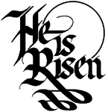
Jesus is Lord . . .
How I Love Him . . .
He’s my Savior . . .
I will praise Him . . .
My Redeemer . . .
Come, Lord Jesus . . .

AMAZING GRACE

- Amazing Grace how sweet the sound
That saved a wretch like me
I once was lost, but now I am found
Was blind but now I see

- Twas Grace that taught my heart to fear
And Grace my fears relieved
How precious did that Grace appear
The hour I first believed
- Through many dangers, toils and snares
I have already come
Tis Grace that brought me safe thus far
And Grace will lead me home

- The Lord has promised good to me
His word my hope secures
He will my shield and portion be
As long as life endures

- When we’ve been there ten thousand years
Bright shining as the sun
We’ve no less days to sing God’s praise
Than when we’ve first begun

- Praise God, Praise God, Praise God, Praise God
Praise God, Praise God, Praise God
Praise God, Praise God, Praise God, Praise God
Praise God, Praise God, Praise God
AS THE DEER
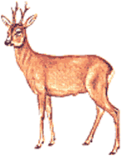
- As the deer panteth for the water
So my soul longeth after Thee

You alone are my heart's desire
And I long to worship Thee

REFRAIN:
You alone are my strength, my shield
To You alone may my spirit yield
You alone are my heart's desire
And I long to worship Thee

- You're my friend and You are my brother
Even though You are a King
I love You more than any other
So much more than anything (REFRAIN)

- I want You more than gold or silver
Only You can satisfy
You alone are the real joy giver
And the apple of my eye (REFRAIN)

BECAUSE HE LIVES

- God sent His Son, they called Him Jesus;
He came to love, heal, and forgive;
He lived and died, to buy my pardon;
An empty grave is there to prove my Savior lives.
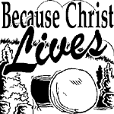
REFRAIN:
- Because He lives, I can face tomorrow;
Because He lives, all fear is gone:
Because I know, He holds the future;
And life is worth the living just because He lives.

- How sweet to hold, a new-born baby;
And feel the pride, and joy he gives;
But greater still, the calm assurance;
This child can face uncertain days, because He lives. (REFRAIN)

- Because He lives, I can face tomorrow;
Because He lives, all fear is gone:
Because I know, He holds the future;
And life is worth the living just because He lives. (REFRAIN)

- And then one day, I'll cross the river;
I'll fight life's final war with pain
And then as death, gives way to vict'ry
I'll see the lights of glory and I'll know He lives. (REFRAIN)
BEHOLD WHAT MANNER OF LOVE


Behold what manner of love the Father has given unto us
Behold what manner of love the Father has given unto us

That we should be called the children of God (sons or daughters)
That we should be called the children of God (sons or daughters)
(repeat)

BE THOU MY VISION

- Be Thou my vision, O Lord of my heart;
Naught be all else to me, save that Thou art;
Thou my best Thought, by day or by night,
Waking or sleeping, Thy presence my light.

- Be Thou my wisdom, and Thou my true Word
I ever with Thee and Thou with me, Lord
Thou my great Father, and I Thy true son,
Thou in me dwelling, and I with Thee one.

- Riches I heed not, nor man’s empty praise,
Thou mine inheritance, now and always,
Thou and Thou only, first in my heart,
High King of heaven, my treasure Thou art.

- High King of heaven, my victory won,
May I reach heaven’s joys, O bright heaven’s Son!
Heart of my own heart, whatever befall,
Still be my Vision, O Ruler of all.

BIND US TOGETHER

REFRAIN

Bind us together, Lord,
Bind us together with cords that cannot be broken

Bind us together, Lord; Bind us together,
Bind us together with love

(verse)

There is only one God
There is only one King
There is only one Body
That is why we sing (REFRAIN)

BREATHE ON ME, BREATH OF GOD

- Breathe on me breath of God
Fill me with life anew
That I may love what Thou dost love
And do what Thou wouldst do.

- Breathe on me breath of God
Until my heart is pure
Until with thee, I will one will,
To do and to endure.


- Breathe on me breath of God
Till I am wholly Thine,
Till all this earthly part of me
Glows with thy fire divine.

- Breathe on me, breath of God
So I shall never die,
But live with Thee the perfect life,
Of Thine eternity.
CHANGE MY HEART, O GOD

REFRAIN:

Change my heart, O God, make it ever true.

Change my heart, O God, may I be like You.

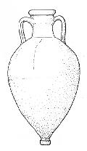
You are the Potter,
I am the clay.
Mold me and make me,
This is what I pray.

(REFRAIN)

DAY BY DAY

- Day by day, day by day
Oh, dear Lord, three things I pray;

To see Thee more clearly,
Love thee more dearly,
Follow Thee more nearly,
Day by day.

- Day by day, day by day
Oh, dear Lord, three things I pray;
To see Thee more clearly,
Love thee more dearly,
Follow Thee more nearly,
Day by day, day by day, by day.

DO LORD

- I’ve got a home in gloryland that outshines the sun
I’ve got a home in gloryland that outshines the sun
I’ve got a home in gloryland that outshines the sun
Look away beyond the blue

REFRAIN:

Do Lord, O do Lord, O do remember me (O Lordy)
Do Lord, O do Lord, O do remember me (Halleluia)
Do Lord, O do Lord, O do remember me,
Look away, beyond the blue

- I took Jesus as my Savior, you take Him too,
I took Jesus as my Savior, you take Him too,
I took Jesus as my Savior, you take Him too,
While He’s calling you (chorus)

- I’ve got a heavenly Father who hears and answers prayers
I’ve got a heavenly Father who hears and answers prayers
I’ve got a heavenly Father who hears and answers prayers
Look away beyond the blue (chorus)

- If you can’t bear the cross, then you can’t wear the crown
If you can’t bear the cross, then you can’t wear the crown
If you can’t bear the cross, then you can’t wear the crown
Look away beyond the blue (chorus)

EMMANUEL

Emmanuel, Emmanuel

His Name is called Emmanuel.

God with us, revealed in us,

His Name is called Emmanuel.

FATHER I ADORE YOU


Father, I adore You;
Lay my life before You;
How I love You.

Jesus, I adore You . . .

Spirit, I adore You . . .

FREELY, FREELY

God forgave my sin in Jesus’ name
I’ve been born again in Jesus’ name
And in Jesus’ name, I come to you
To share His love as He told me to
He said, (REFRAIN)
REFRAIN

Freely, freely, you have received,
Freely, freely give.
Go in My name and because you believe
Others will know that I live.

All pow’r is giv’n in Jesus’ name,
In earth and heav’n in Jesus’ name,
And in Jesus’ name I come to you
To share His pow’r as He told me to
He said, (REFRAIN)

(The) GIFT OF LOVE

- Though I may speak with bravest fire,
And have the gift to all inspire,
And have not love, my words are vain,
And sounding brass, and hopeless gain.

- Though I may give all I possess,
And striving so my love profess,
But not be given by love within,
The profit soon turns strangely thin.

- Come, Spirit, come, our hearts control,
Our spirits long to be made whole,
Let inward love guide every deed,
By this we worship, and are freed.
GIVE THANKS


Give thanks with a grateful heart,
Give thanks to the Holy One;
Give thanks because it’s given
Jesus Christ, His Son.

(Repeat)

And now let the weak say, “I am strong;”
Let the poor say, “I am rich,”
Because of what the Lord has done for us.

(Repeat from the beginning)

Give thanks . . .

GLORIFY THY NAME


- Father, we love Thee,
we praise Thee, we adore Thee,
Glorify Thy name in all the earth.

Glorify Thy name,
Glorify Thy name,
Glorify Thy name in all the earth

- Jesus, we love Thee, we praise Thee, we adore Thee . . .

- Spirit, we love Thee, we praise Thee, we adore Thee . . .

GOD IS SO GOOD

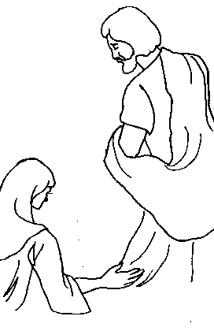
- God is so good. God is so good.
God is so good. He’s so good to me.

- He took my sin. He took my sin.
He took my sin. He’s so good to me

- Now I am free. Now I am free.
Now I am free. He’s so good to me.

- God is so good. He took my sin.
Now I am free. He’s so good to me.
GRACE GREATER THAN OUR SIN

- Marvelous grace of our loving Lord,
Grace that exceeds our sin and our guilt.
Yonder on Calvary’s mount out-poured,
There where the blood of the Lamb was spilt.

REFRAIN:

Grace, grace, God’s grace, grace that will pardon and cleanse within.
Grace, grace, God’s grace, grace that is greater than all our sin.

- Sin and despair, like the sea waves cold,
Threaten the soul with infinite loss,
Grace that is greater yes, grace untold,
Points to the refuge, the mighty cross. (REFRAIN)

- Dark is the strain that we cannot hide,
What can avail to wash it away?
Look! There is flowing a crimson tide,
Brighter than snow you may be today. (REFRAIN)

- Marvelous, infinite, matchless grace,
Freely bestowed on all who believe,
You that are longing to see His face,
Will you this moment His grace receive? (REFRAIN)


HALLELU, HALLELU

Part One: Part Two:

Hallelu, Hallelu, Hallelu, Hallelujah Praise ye the Lord!
Hallelu, Hallelu, Hallelu, Hallelujah Praise ye the Lord!
Praise ye the Lord! Hallelujah!
Praise ye the Lord! Hallelujah!
Praise ye the Lord! Hallelujah!

Both Parts:
Praise ye the Lord!

HAVE THINE OWN WAY, LORD

- Have Thine own way, Lord. Have Thine own way.
Thou art the potter, I am the clay.
Mold me and make me, after thy will,
While I am waiting, yielded and still.

- Have Thine own way, Lord. Have Thine own way.
Search me and try me, Master, today.
Whiter than snow, Lord, Wash me just now.
As in Thy presence, humbly I bow.

- Have Thine own way, Lord. Have Thine own way.
Wounded and weary, help me, I pray.
Power, all power, surely is Thine.
Touch me and heal me, Savior divine.

- Have Thine own way, Lord. Have Thine own way.
Hold o’er my being, absolute sway.
Fill with Thy spirit, till all shall see.
Christ only, always, living in me.

HAVE YOU SEEN JESUS MY LORD?


REFRAIN:
Have you seen Jesus my Lord?
He’s here in plain view
Take a look, open your eyes,
He’ll show it to you.

- Have you ever looked at the sunset
With the sky mellowin’ red
And the clouds suspended like feathers?
Then I say, you’ve seen Jesus my Lord (REFRAIN)

- Have you ever stood at the ocean
With the white foam at your feet,
Felt the endless thunderin’ motion?
Then I say, you’ve seen Jesus my Lord (REFRAIN)

- Have you ever looked at the cross
With a man hangin’ in pain
And the look of love in His eyes?
Then I say, you’ve seen Jesus my Lord (REFRAIN)

- Have you ever stood in the family
With the Lord there in your midst
Seen the face of Christ on your brother? (sister?)
Then I say, you’ve seen Jesus my Lord (REFRAIN)
HERE I AM LORD

- I, the Lord of sea and sky, I have heard my people cry
All who dwell in dark and sin, My hand will save
I, who made the stars of night, I will make their darkness bright
Who will bear my Light to them? Whom shall I send?


REFRAIN:

Here I am Lord, Is it I, Lord?
I have heard You calling in the night.
I will go, Lord, if You lead me.
I will hold Your people in my heart.

- I, the Lord of snow and rain, I have borne My peoples’ pain.
I have wept for love of them. They turn away.
I will break their hearts of stone, give them hearts for love alone.
I will speak My Word to them. Whom shall I send?
(REFRAIN)

- I, the Lord of wind and flame, I will tend the poor and lame.
I will set a feast for them. My hand will save.
Finest bread I will provide, till their hearts be satisfied.
I will give My life to them. Whom shall I send?
(REFRAIN)

HE IS LORD

He is Lord. He is Lord.
He is risen from the dead

And He is Lord.

Every knee shall bow,
Every tongue confess
That Jesus Christ is Lord

HE’S GOT THE WHOLE WORLD IN HIS HANDS

REFRAIN:

- He’s got the whole world in His hands,
He’s got the whole world in His hands,
He’s got the whole world in His hands,
He’s got the whole world in His hands.

- He’s go the wind and the rain, in His hands,
He’s go the wind and the rain, in His hands,
He’s go the wind and the rain, in His hands,
He’s got the whole world in His hands. (REFRAIN)

- He’s got the tiny little baby, in His hands,
He’s got the tiny little baby, in His hands,
He’s got the tiny little baby, in His hands,
He’s got the whole world in His hands. (REFRAIN)

- He’s got you and me brother, in His hands,
He’s got you and me sister, in His hands,
He’s got you and me brother, in His hands,
He’s got the whole world in His hands. (REFRAIN)

- He’s got everybody here, in His hands,
He’s got everybody here, in His hands,
He’s got everybody here, in His hands,
He’s got the whole world in His hands. (REFRAIN)

HIS NAME IS WONDERFUL

His Name is Wonderful,
His Name is Wonderful,
His Name is Wonderful,
Jesus, my Lord.

He is the mighty King,
Master of everything,
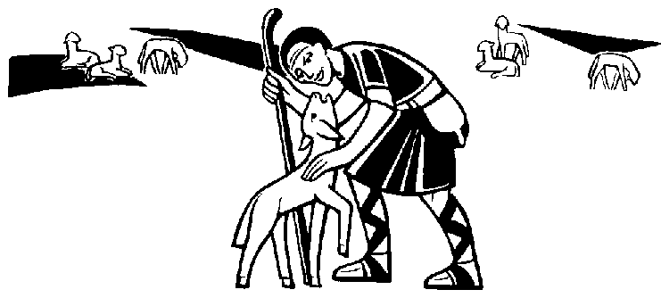
His Name is Wonderful,
Jesus, my Lord.

He’s the great Shepherd,
The Rock of all ages,
Almighty God is He.

Bow down before Him,
Love and adore Him,
His Name is Wonderful,
Jesus, my Lord.
HOLY GROUND

This is Holy ground, we’re standing on Holy ground
And the Lord is here and where He is . . is Holy
This is Holy ground, we’re standing on Holy ground
And the Lord is here and where He is . . . is Holy

These are Holy hands, we’re lifting up Holy hands
He works through these hands and so these hands are Holy
These are Holy hands, we’re lifting up Holy hands
He works through these hands and so these hands are Holy

- - - - - - - - - - - - - - - - - - - - - - - - - - - - - - - - - - - - - - - - -

We are standing . . . on Holy ground.
And I know that there are angels all around.
Let us praise . . . Jesus now.
We are standing in His presence on Holy ground.

HOLY IS THE LORD

Holy . . . Holy . . . Holy is the Lord.
Holy . . . Holy . . . Holy is the Lord.

HYMN OF PROMISE

In the bulb there is a flower, in the seed, an apple tree;
In cocoons, a hidden promise, butterflies will soon be free!
In the cold and snow of winter there’s a spring that waits to be,
Unrevealed until its season, something God alone can see.

There’s a song in every silence, seeking word and melody;
There’s a dawn in every darkness, bringing hope to you and me,
From the past will come the future; what it holds, a mystery,
Unrevealed until its season, something God alone can see.

In our end is our beginning; in our time, infinity;
In our doubt there is believing; in our life, eternity.
In our death, a resurrection; at the last, a victory,
Unrevealed until its season, something God alone can see.

HUMBLE THYSELF

Grp 1. Humble thyself in the sight of the Lord.
Grp. 2. Humble thyself in the sight of the Lord

Grp 1. Humble thyself in the sight of the Lord.
Grp. 2. Humble thyself in the sight of the Lord

Grp. 1. And He . . . shall lift . . . you up (Higher & Higher)
Grp. 2. And He . . . shall lift . . . you up (Higher & Higher)

Grp. 1. And He . . . shall lift . . . you up
Grp. 2. And He . . . shall lift . . . you up

I AM LOVED

I am loved, I am loved, I can risk loving you
For the One who knows me best loves me most.
I am loved, you are loved, won’t you please take my hand?
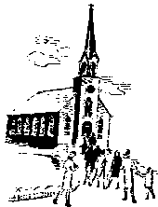
We are free to love each other,
We are loved.
I AM THE CHURCH

REFRAIN:
I am the church! You are the church!
We are the church together!
All who follow Jesus all around the world
Yes, we’re the church together!

- The church is not a building, the church is not a steeple,
The church is not a resting place, the church is a people. (REFRAIN)

- We’re many kinds of people with many kinds of faces,
All colors and all ages, too, from all times and places. (REFRAIN)

- Sometimes the church is marching, sometimes it’s bravely burning,
Sometimes it’s riding, sometimes hiding, always it’s learning. REFRAIN)

- And when the people gather there’s singing and there’s praying,
There’s laughing and there’s crying sometimes, all of it saying. (REFRAIN)

- At Pentecost some people receive the Holy Spirit,
And told the Good News through the world to all who would hear it. (REFRAIN)

- I count if I am ninety, or nine and just a baby,
There’s one thing I am sure about, and I don’t mean maybe. (REFRAIN)

I HAVE DECIDED TO FOLLOW JESUS

- I have decided to follow Jesus. I have decided to follow Jesus.
I have decided to follow Jesus. No turning back, no turning back.

- The world behind me, the cross before me. The world behind me, the cross before me.
- The world behind me, the cross before me. No turning back, no turning back.

- Tho’ none go with me, still I will follow. Tho’ none go with me, still I will follow.
Tho’ none go with me, still I will follow. No turning back, no turning back.

- Where Jesus leads me, I’ll surely follow. Where Jesus leads me, I’ll surely follow.
Where Jesus leads me, I’ll surely follow. No turning back, no turning back.

- Sing glory, glory, and Hallelujah. Sing glory, glory, and Hallelujah.
Sing glory, glory, and Hallelujah. No turning back, no turning back.

I LOVE TO TELL THE STORY

- I love to tell the story of unseen things above
Of Jesus and His glory, of Jesus and His love
I love to tell the story because I know ‘tis true
It satisfies my longings as nothing else can do

REFRAIN:

I love to tell the story, ‘Twill be my theme in glory
To tell the old, old story of Jesus and His love

- I love to tell the story, more wonderful it seems
Than all the golden fancies of all our golden dreams
I love to tell the story, it did so much for me
And that is just the reason, I tell it now to thee (REFRAIN)

- I love to tell the story, ‘Tis pleasant to repeat
What seems each time I tell it, more wonderfully sweet
love to tell the story, for some have never heard
The message of salvation from God’s own Holy Word (REFRAIN)

- I love to tell the story, for those who know it best
Seem hungering and thirsting to hear it like the rest
And when, in scenes of glory, I sing the new, new song
‘Twill be the old, old story that I have loved so long (REFRAIN)
I LOVE YOU LORD

I love You, Lord, and I lift my voice
To worship You, O my soul rejoice.
Take joy my King, in what You hear
May it be a sweet, sweet sound in Your ear.

I LOVE YOU WITH THE LOVE OF THE LORD

Oh, I love you with the love of the Lord.
Yes, I love you with the love of the Lord.
I can see in you, the glory of my King.
And I love you with the love of the Lord.

I WILL CALL UPON THE LORD

I will call upon the Lord (echo)
Who is worthy to be praised (echo)
So shall I be saved from my enemies (echo)

The Lord liveth and blessed be the Rock (clap, clap)
And may the God of my salvation be exalted (repeat)

IN HIS TIME

In His time, in His time,
He makes all things beautiful in His time.
Lord, please show me every day,
As You’re teaching me Your way,
That You do just what You say,
In Your time.

In Your time, in Your time,
You make all things beautiful in Your time.
Lord, my life to You I bring,
May each song I have to sing,
Be to You a lovely thing,
In Your time.

IN REMEMBRANCE

In remembrance of Me, eat this bread.
In remembrance of Me, drink this wine.
In remembrance of Me, pray for the time,
When God’s own will be done.

In remembrance of Me, heal the sick.

In remembrance of Me, feed the poor.
In remembrance of Me, open the door,
Let your brother and sister in, let them in

Take, eat, and be comforted,
Drink, and remember too,
That this is My body and precious blood,
Shed for you, shed for you.

In remembrance of Me, search for truth.
In remembrance of Me, always love.
In remembrance of Me, don’t look above,
But in your heart look for God.

I’VE GOT THAT JOY, JOY, JOY JOY

I’ve got that joy, joy, joy, joy, down in my heart,
Down in my heart, down in my heart,
I’ve got that joy, joy, joy, joy, down in my heart,
Down in my heart to stay.

I’ve got that peace that passeth understanding,
Down in my heart . . . . .

I’ve got that love of Jesus, love of Jesus,
Down in my heart . . . . .

I WANT TO PRAISE YOU, LORD

I want to praise You, Lord, much more than I do.
I want to praise You, Lord, much more than I do.
Learn to seek Your face, and the knowledge of Your grace,
I want to praise You.

I want to know You, Lord, much more than I do . . .

I want to love You, Lord, much more than I do . . .

I want to serve You, Lord, much more than I do . . .

I want to praise You, Lord, much more than I do . . .

I WILL ENTER HIS GATES

I will enter His gates with thanksgiving in my heart,
I will enter His courts with praise;
I will say “This is the day that the Lord hath made,
I will rejoice for He hath made me glad”

He hath made me glad, He hath made me glad
I will rejoice for He hath made me glad;
He hath made me glad, He hath made me glad
I will rejoice for He hath made me glad.

JESUS IN THE MORNING

Praise Him, praise Him, praise Him in the morning;
Praise Him in the noon-time;

Praise Him, praise Him,
Praise Him when the sun goes down.
Jesus, Jesus, Jesus in the morning . . .

Serve him, serve Him, serve Him in the morning . . .

Love Him, love Him, love Him in the morning . . .

Thank Him, thank Him, thank Him in the morning . . .

JESUS, JESUS

Jesus, Jesus . . . Can I tell You how I feel?
You have given me Your Spirit, I love You so.

. . . You have given me Your riches, I love You so.

. . . You have given me Your life, I love You so.

. . . You have given me Your blessings, I love You so.

. . . You have given me Your love, I love You so.

. . . You have given me Your peace, I love You so.

. . . You have given me Your blood, I love You so.

Love, Love, Love, Love. Christians, this is your call;
Love your neighbor as yourself, for God loves us all.

JESUS, LORD TO ME


Jesus, Jesus, Lord to me;
Master, Savior, Prince of Peace,
Ruler of my heart today,
Jesus, Lord to me.

JESUS LOVES ME

Jesus loves me, this I know,
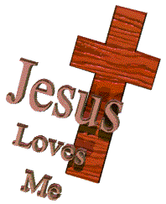
For the Bible tells me so.
Little ones to Him belong,
They are weak, by He is strong.

REFRAIN:

Yes, Jesus loves me. Yes, Jesus loves me;
Yes, Jesus loves me. The Bible tells me so.

Jesus loves me, He who died,
Heaven’s gate to open wide.
He will wash away my sin,
Let His little child come in (REFRAIN)

Jesus loves me, He will stay,
Close beside me all the way.
If I love Him, when I die,
He will take me home on high (REFRAIN)

JESUS, NAME ABOVE ALL NAMES

Jesus, name above all names, beautiful Savior, glorious Lord.
Emmanuel, God is with us, blessed redeemer, Living Word.

JESUS, REMEMBER ME

Jesus remember me, when You come into Your kingdom.
Jesus remember me, when You come into Your kingdom.

KUMBAYA

Kumbaya, My Lord, Kumbaya. Kumbaya, My Lord, Kumbaya.
Kumbaya, My Lord, Kumbaya. O Lord, Kumbaya.

Someone’s crying Lord, Kumbaya . . .

Someone’s singing Lord, Kumbaya . . .

Someone’s praying Lord, Kumbaya . . .

Come by here, My Lord, Come by here . . .

LET US BREAK BREAD TOGETHER


Let us break bread together on our knees.
Let us break bread together on our knees.
When I fall on my knees, with my face to the rising sun,

O Lord, have mercy on me.

Let us drink wine together on our knees . . .

Let us praise God together on our knees . . .

LET’S JUST PRAISE THE LORD

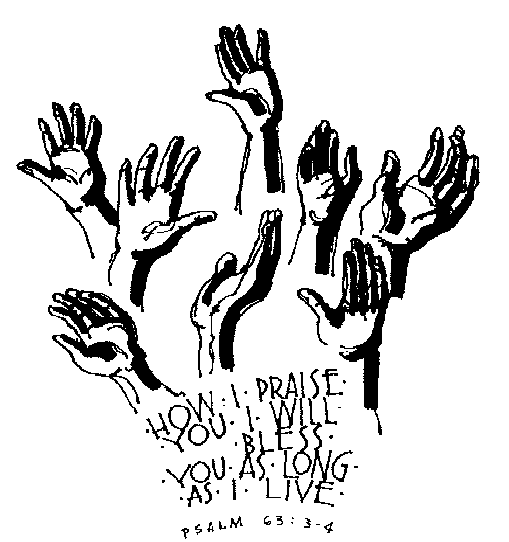
Let’s just praise the Lord, praise the Lord,
Let’s just lift our hands toward heaven and praise the Lord.
Let’s just praise the Lord, praise the Lord,
Let’s just lift our hands toward heaven and praise the Lord.

LORD, BE GLORIFIED

In my life, Lord, be glorified, be glorified.
In my life, Lord, be glorified today.

In my song, Lord, be glorified, be glorified.
In my song, Lord, be glorified today.

In Your church, Lord, be glorified, be glorified.
In Your church, Lord, be glorified today.
LORD, I LIFT YOUR NAME ON HIGH

Lord, I lift Your name on high;
Lord, I love to sing Your praises.
I’m so glad You’re in my life;

I’m so glad You came to save us.

You came from heaven to earth,
To show the way.
From the earth to the cross,
My debt to pay.
From the cross to the grave, from the grave to the sky;
Lord, I lift Your name on high!

LORD OF THE DANCE

I danced in the morning when the world was begun,
And I danced in the moon and the stars and the sun,
And I came down from Heaven and I danced on the earth,
At Bethlehem I had my birth.

REFRAIN:

Dance, then, wherever you may be;
“I am the Lord of the dance,” said He
And I’ll lead you all wherever you may be,
And I’ll lead you all in the dance, said He

I danced for the scribe and the pharisee
But they would not dance, and they would not follow me;
I danced for the fishermen, for James and John,
They came to me, and the dance went on. (REFRAIN)

I danced on the Sabbath when I cured the lame,
The holy people said it was a shame;
They whipped and the stripped and they hung me high,
And they left me there on a cross to die. (REFRAIN)

I danced on a Friday and the sky turned black,
It’s hard to dance with the devil on your back;
They buried my body and they thought I’d gone,
But I am the dance and I still go on. (REFRAIN)

They cut me down and I leapt up high,
I am the life that’ll never, never die;
I’ll live in you if you’ll live in Me,
I am the Lord of the dance, said He. (REFRAIN)
LOVE LIFTED ME

- I was sinking deep in sin, far from the peaceful shore,
Very deeply stained within, sinking to rise no more,
But the Master of the sea, heard my despairing cry,
From the waters lifted me, now safe am I.

REFRAIN:

Love lifted me! Love lifted me!
When nothing else could help, Love lifted me.
Love lifted me! Love lifted me!
When nothing else could help, Love lifted me.

- All my heart to Him I give, ever to Him I’ll cling,
In His blessed presence live, ever His praises sing,
Love so mighty and so true merits my soul’s best songs,
Faithful, loving service, too, to Him belongs (REFRAIN)

- Souls in danger, look above, Jesus completely saves,
He will lift you by His love out of the angry waves,
He’s the Master of the sea, billows His will obey,
He your Savior wants to be – be saved today. (REFRAIN)

LORD YOU ARE MORE PRECIOUS

Lord, You are more precious than silver.
Lord, You are more costly than gold.
Lord, You are more beautiful than diamonds.
(and) Nothing I desire compares with You.

MORNING HAS BROKEN

Morning has broken like the first morning,
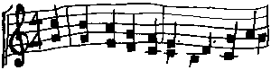
Blackbird has spoken like the first bird.
Praise for the singing! Praise for the morning!
Praise for them, springing fresh from the Word!

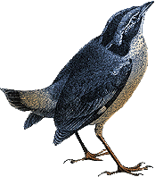
Sweet the rain’s new fall, sun-lit from heaven,
Like the first dew-fall on the first grass.
Praise for the sweetness of the wet garden,
Sprung in completeness where His feet pass.

Mine is the sunlight! Mine is the morning,
Born of the one light Eden say play!
Praise with elation, praise every morning,
God’s re-creation of the new day!
MY JESUS, I LOVE THEE

My Jesus, I love Thee, I know Thou art mine,
For Thee, all the follies of sin I resign;
My gracious Redeemer, my Savior art Thou;
If ever I loved Thee, my Jesus ‘tis now.

I’ll love Thee in life, I will love Thee in death,
And praise Thee as long as Thou lendest me breath;
And say when the death-dew lies cold on my brow;
If ever I loved Thee, my Jesus ‘tis now.

In mansions of glory and endless delight,
I’ll ever adore Thee in heaven so bright;
I’ll sing with the glittering crown on my brow;
If ever I loved Thee, my Jesus ‘tis now.

MY TRIBUTE

To God be the glory, to God be the glory,
To God be the glory for the things he has done.
With His blood He has saved me; with his power He has raised me;
To God be the glory for the things he has done.

OH, HOW HE LOVES YOU AND ME

Oh, how He loves you and me


Oh, how He loves you and me


He gave His life,

What more could He give?

Oh, how He loves you
Oh, how He loves me
Oh, how He loves you and me

OH, HOW I LOVE JESUS


- There is a name I love to hear
I love to sing its worth.
It sounds as music in mine ear,
The sweetest name on earth.

REFRAIN:

Oh, how I love Jesus, Oh, how I love Jesus.
Oh, how I love Jesus, because He first loved me.

- It tells me of a Savior’s love,
Who died to set me free.
It tells me of His precious blood,
The sinner’s perfect plea (REFRAIN)

- It tells me what my Father hath,
In store for every day.
And though I tread a darksome path,
Yields sunshine all the way (REFRAIN)

- It tells of One whose loving heart,
Can feel my deepest woe.
Who in each sorrow bears a part,
That none can bear below (REFRAIN)

ONE BREAD, ONE BODY

REFRAIN:

One bread, one body, one Lord for all,
One cup of blessing which we bless.
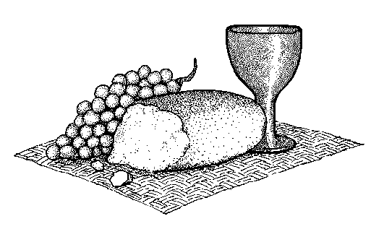
And we, though many, throughout the earth,
We are one body in this one Lord.

Gentile or Jew, servant or free,
Woman or man, no more (REFRAIN)

Many the gifts, many the works,
One in the Lord of all (REFRAIN)

Grain for the fields, scattered and grown,
Gathered to one, for all (REFRAIN)

ONLY JESUS

Only Jesus, Jesus only,
After all the prayer,
After all the care.
After searching, after seeking,
Jesus only, only Jesus.

Gentle breezes of compassion,
Jesus only, only Jesus.
In our deepest joy,
In our deepest pain,
Jesus only, only Jesus.

OPEN OUR EYES

Open our eyes, Lord, we want to see Jesus,
To reach out and touch Him,
And say that we love Him.
Open our ears, Lord, and help us to listen,
Open our eyes, Lord, we want to see Jesus

Our God is an awesome god

Our God (echo) is an Awesome God
And reigns (echo) from heaven above
With wisdom power and love
Our God is an Awesome God

OUR GOD REIGNS

- How lovely on the mountains are the feet of Him
Who brings good news, good news
Announcing peace, proclaiming news of happiness
Saying to Zion Your God reigns
Your God reigns, Your God reigns.

- He had not stately form, He had no majesty
That we should be drawn to Him
He was despised and we took no account of Him
Yet now He reigns with the Most High
Now He reigns . . . Now He reigns.

- It was our sin and guilt that bruised and wounded Him
It was our sin that brought Him down.
When we like sheep had gone astray, our shepherd come
And on His shoulders bore our shame
On His shoulders . . . on His shoulders
On His shoulders He bore our shame.

- Meek as a lamb that’s led out to the slaughter-house
Dumb as a sheep - - before its shearer.
His life ran down upon the ground like pouring rain
That we might be - - born again
That we might be . . . That we might be
That we might be born again.

- Out from the tomb He came with grace and magesty
He is alive - - He is alive
God loves us so - - see here His hands, His feet, His side
Yes, we know - - He is alive
He is alive . . . He is alive
He is alive . . . He is alive.

- How lovely on the mountains are the feet of Him
Who brings good news, good news
Announcing peace, proclaiming news of happiness

Our God reigns . . . Our God reigns
Our God reigns . . . Our God reigns
Our God reigns . . . Our God reigns.

PASS IT ON

It only takes a spark to get a fire going,
And soon all those around, can warm up to its glowing,
That’s how it is with God’s love, once you’ve experienced it,
You spread His love to everyone.
You want to pass it on.

What a wondrous time is spring when all the trees are budding,
The birds begin to sing, the flowers start their blooming,
That’s how it is with God’s love, once you’ve experienced it,
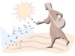
You want to sing, it’s fresh like spring,
You want to pass it on.

I wish for you my friends, this happiness that I’ve found,
You can depend on Him, it matters not where you’re bound,
I’ll shout it from the mountaintop, (PRAISE GOD!)
I want my world to know,
The Lord of Love has come to me,
I want to pass it on.

I’ll shout it from the mountaintop, (PRAISE GOD!)
I want my world to know,
The Lord of Love has come to me,
I want . . . . to pass . . . . it on.

PEACE IS FLOWING

Peace is flowing like a river, flowing out of you and me
Flowing out into the desert, setting all the captives free.

His Love is flowing . . .
His healing’s flowing . . .

Joy is flowing . . .

Faith is flowing . . .

Hope is flowing . . .

Alleluia, Alleluia . . .

PRAISE THE LORD TOGETHER (ROUND)

Praise the Lord together singing,
Alleluia, Alleluia, Alleluia.

Come into His presence singing,
Alleluia, Alleluia, Alleluia.

Come into His presence singing,
Jesus is Lord . . .

Come into His presence singing,
Worthy is the lamb . . .

Come into His presence singing,
Glory to God . . .

Praise the Name of Jesus


Praise the name of Jesus. Praise the name of Jesus.
He’s my rock. He’s my fortress.
He’s my deliverer In Him will I trust.
Praise the name of Jesus.

REJOICE IN THE LORD ALWAYS

Rejoice in the Lord always and again I say rejoice.
Rejoice in the Lord always and again I say rejoice.

Rejoice!
Rejoice!

And again I say rejoice!

Rejoice!
Rejoice!
And again I say rejoice!

(Repeat)

RISE AND SHINE

REFRAIN:

Rise and shine and give God the glory, glory.
Rise and shine and give God the glory, glory.
Rise and shine and give God the glory, glory.
Children of the Lord.

- The Lord told Noah, “There’s gonna be a floody, floody”

Lord told Noah, “There’s gonna be a floody, floody”
Get those animals out of the muddy, muddy.
Children of the Lord. (REFRAIN)

- The Lord told Noah to build him an arky, arky.
Lord told Noah to build him an arky, arky.
Build it out of gopher barky, barky.
Children of the Lord. (REFRAIN)

- The animals, the animals, they came in by twosies, twosies.
Animals, the animals, the came in by twosies, twosies.
Elephants and kanaroosies, roosies.
Children of the Lord. (REFRAIN)

- It rained and poured for forty daysies, daysies.
Rained and poured for forty daysies, daysies.
Almost drove those animals crazy, crazy.
Children of the Lord. (REFRAIN)

- The sun came out and dried up the landy, landy.
The sun came out and dried up the landy, landy.
Everything was fine and dandy, dandy.
Children of the Lord. (REFRAIN)

- The animals, the animals, they came off in threesies, threesies.
Animals, the animals, they came off in threesies, threesies.
Elephants and chimpanzeesys, zeesys,
Children of the Lord. (REFRAIN)

SANCTUARY

Lord prepare me to be a sanctuary,
Pure and holy, tried and true;
With thanksgiving,
I’ll be a living
Sanctuary for You.

SEEK YE FIRST

Seek ye first the kingdom of God, and His righteousness,
And all these things shall be added unto you,

Allelu, Alleluia.

Ask and it shall be given unto you, see and ye shall fine,
Knock and the door shall be opened unto you,
Allelu, Alleluia.

Man does not live by bread alone, but by every word,
That proceeds from the mouth of God,
Allelu, Alleluia.

SING ALLELUIA TO THE LORD
(Emmaus Alleluia)

Part One. Part Two.

Sing Alleluia to the Lord Sing Alleluia to the Lord.

Sing Alleluia to the Lord Sing Alleluia to the Lord.

Sing Alleluia, Sing Alleluia Sing Alleluia, Sing Alleluia

Both Parts

Sing alleluia to the Lord

SOMETHING BEAUTIFUL

Something beautiful, Something good;
All my confusion, He understood;
All I had to offer Him
Was brokenness and strife;
But He made something beautiful of my life.

SPIRIT OF THE LIVING GOD


Spirit of the living God, fall afresh on me,
Spirit of the living God, fall afresh on me.
Melt me, mold me, fill me, use me,
Spirit of the living God, fall afresh on me.

SPIRIT SONG


O let the Son of God enfold you
With His spirit and His love
Let Him fill your heart and satisfy your soul.
O let Him have the things that hold you,
And His spirit, like a dove,
Will descend upon your life and make you whole.

REFRAIN:

Jesus, O Jesus, Come and fill your lambs
Jesus, O Jesus, Come and fill your lambs

O come and sing this song with gladness,
As your hearts are filled with joy,
Lift your hands in sweet surrender to His name.

O give Him all your tears and sadness,
Give Him all your years of pain,
And you’ll enter into life in Jesus’ name.

SURELY THE PRESENCE OF THE LORD IS IN THIS PLACE

Surely the presence of the Lord is in this place,
I can feel His mighty power and His grace.

I can hear the brush of angels’ wings,
I see glory on each face,
Surely the presence of the Lord is in this place.

(REPEAT TWICE)

TAKE MY LIFE

Take my life, and let it be consecrated, Lord, to Thee.
Take my moments and my days; Let them flow in ceaseless praise,
Take my hands, and let them move; At the impulse of Thy love.
Take my feet, and let them be swift and beautiful for Thee.
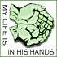
Take my voice, and let me sing; Always, only for my king.
Take my lips, and let them be filled with messages from Thee.
Take my silver and my gold; Not a mite would I withhold.
Take my intellect, and use every pow’r as Thou shalt choose.

Take my will, and make it Thine; It shall be no longer mine.
Take my heart, it is Thine own; It shall be Thy royal throne.
Take my love, my Lord, I pour at Thy feet its treasure store.
Take myself, and I will be ever, only, all for Thee.

TAKE OUR BREAD

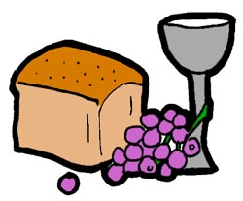
REFRAIN:

Take our bread, we ask You.
Take our hearts, we love You.
Take our lives, oh Father,
We are Yours, we are Yours.

Yours as we stand at the table You set,
Yours as we eat the bread our hearts can’t forget,
We are the sign of Your life with us yet,
We are Yours, we are Yours. (REFRAIN)

Your holy people standing washed in Your blood,
Spirit-filled yet hungry, we await Your food,
We are poor, but we’ve brought ourselves the best we could,
We are Yours, we are Yours. (REFRAIN)

TAKE TIME TO BE HOLY

- Take time to be holy, speak oft with thy Lord, abide in Him always,
And feed on His Word; make friends of God’s children. Help those who
Are weak, forgetting in nothing His blessing to seek.

- Take time to be holy, the world rushed on; spend much time in secret
With Jesus alone; by looking to Jesus, like Him thou shalt be; thy
Friends in thy conduct His likeness shall see.

- Take time to be holy, let Him be thy guide, and run not before Him,
Whatever betide; in joy or in sorrow, still follow the Lord,
And, looking to Jesus, Still Trust in His Word.

- Take time to be holy, be calm in thy soul; each thought and each motive
Beneath His control; thus led by His spirit to fountains of love, thou soon
Shalt be fitted for service above. Amen.
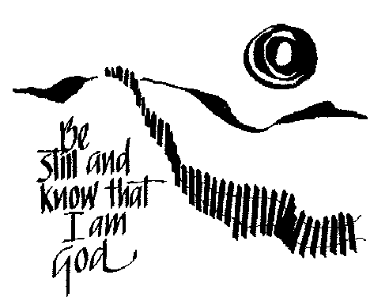

THE JOY OF THE LORD

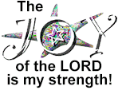
REFRAIN:

The joy of the Lord is my strength
The joy of the Lord is my strength
The joy of the Lord is my strength
The joy of the Lord is my strength

- The word of faith is nigh thee, yea in my mouth. (Repeat twice)
The joy of the Lord is my strength (REFRAIN)

- He gives me living water and I thirst no more. (Repeat twice)
The joy of the Lord is my strength (REFRAIN)

- Since you have His joy you may shout with it. (Repeat twice)
The joy of the Lord is my strength (REFRAIN)

- Ha, ha, ha, ha, ha, ha, ha, ha, ha, ha, ha, ha. (Repeat twice)
The joy of the Lord is my strength (REFRAIN)

THE LORD HAS A WILL

I need you Lord, in all I do,
You’re always there to see me through.
I can’t get by unless I lean on you Lord.

REFRAIN:

The Lord has a will, and I have a need to follow that will,
To humbly be still, to rest in it, nest in it, fully be blest in it,
Following my Father’s will.

Your law above is in my heart,
you wrote it there, it won’t depart.
It lights my way and keeps me out of the dark. (REFRAIN)

I thank you Lord, you put a song
into my life and there it’s grown;
Its roots are deep for living waters are known. (REFRAIN)

THE SWEETEST NAME OF ALL

Jesus, You’re the sweetest name of all.
Jesus, You always hear me when I call.
Oh Jesus, You pick me up each time I fall.
You’re the sweetest, the sweetest name of all.

Oh Jesus, how I love to praise Your name.
Jesus, You’re still the first, the last, the same.
Oh Jesus, You died and took away my shame.
You’re the sweetest, the sweetest name of all.

Jesus, You’re the soon and coming King.
Jesus, we need the love that You can bring.
Oh Jesus, we lift our voices up and sing.
You’re the sweetest, the sweetest name of all.

(REPEAT FIRST VERSE)

THERE’S SOMETHING ABOUT THAT NAME

Jesus, Jesus, Jesus. There’s just something about that name!
Master, Savior, Jesus. Like the fragrance after the rain;
Jesus, Jesus, Jesus. Let all Heaven and earth proclaim;
Kings and kingdoms will all pass away,
But there’s something about that name.

THEY THAT WAIT UPON THE LORD

REFRAIN:


They that wait upon the Lord,
Shall renew their strength,
They shall mount up with wings as eagles.
They shall run and not be weary,
They shall walk and not faint,
Teach me Lord, teach me, Lord, to wait.

Teach me Lord to wait,
While hearts are aflame,
Let me humble my pride,
And call on Your name.
Keep my faith renewed,
My eyes on Thee,
Let me be on this earth,
What you’d have me to be. (REFRAIN)

THEY’LL KNOW WE ARE CHRISTIANS
We are one in the Spirit, we are one in the Lord.
We are one in the Spirit, we are one in the Lord.
And we pray that all unity may one day be restored.

REFRAIN:

And they’ll know we are Christians by our love, by our love,
Yes, they’ll know we are Christians by our love.

We will walk with each other, we will walk hand in hand.
We will walk with each other, we will walk hand in hand.
And together we’ll spread the news that God is in our land. (REFRAIN)

We will work with each other, we will work side by side.
We will work with each other, we will work side by side.
And we’ll guard each one’s dignity and save each one’s pride. (REFRAIN)

All praise to the Father from whom all things come,
And all praise to Christ Jesus, His only Son,
And all praise to the Spirit who makes us one. (REFRAIN)

THIS IS THE DAY

Part One: Part Two:

This is the day. This is the day.
That the Lord hath made. That the Lord hath made.
Let us rejoice. Let us rejoice.
And be glad in it. And be glad in it.
This is the day that the Lord hath made. Let us rejoice and be glad in it.
This is the day. This is the day.

Both Parts:

That the Lord hath made.

THOU ART WORTHY

Thou art worthy. Thou art worthy. Thou art worthy, O Lord.
Thou art worthy to receive glory, glory and honor and power.
For Thou hast created, hast all things created,
For Thou has created all things.
And for Thy pleasure they are created. Thou art worthy, O Lord.

THROUGH IT ALL

Through it all,
Through it all,
I’ve learned to trust in Jesus,
I’ve learned to trust in God.

Through it all,
Through it all,
I’ve learned to depend upon His Word.

(Repeat)

THY WORD
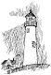
REFRAIN:

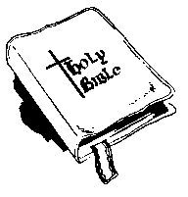
Thy Word is a lamp unto my feet
And a light unto my path
Thy Word is a lamp unto my feet
And a light unto my path

- And when I feel afraid, think I’ve lost my way
Still You’re there right beside me.
Nothing will I fear as long as You are near
Please be near me to the end.
(REFRAIN)

- I will not forget Your love for me and yet
My heart forever is wandering.
Jesus be my guide and hold me to Your side
And I will love You to the end.
(REFRAIN)

TURN YOUR EYES UPON JESUS


Turn your eyes upon Jesus. Look full in His wonderful face.
And the things of earth will grow strangely dim,
In the light of His glory and grace.

WE BOW DOWN

- You are Lord of creation and Lord of my life, Lord of the land and the
Sea. You were Lord of the heavens before there was time and Lord of all
Lords you will be.

- We bow down and we worship you Lord
We bow down and we worship you Lord
We bow down and we worship you Lord
And Lord of all lords you will be

- You are King of creation and King of my life, King of the land and the
Seas. You were King of the heavens before there was time and King
Of kings you will be.
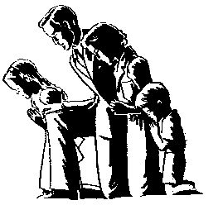
- We bow down and we crown you the King
We bow down and we crown you the King
We bow down and we crown you the King
And King of all kings you will be.

- We bow down and we worship you Lord
We bow down and we worship you Lord
We bow down and we worship you Lord
And Lord of all lords you will be.

- We bow down and we crown you the King
We bow down and we crown you the King
We bow down and we crown you the King
And King of all kings you will be.

WE BRING THE SACRIFIECE

We bring the sacrifice of praise,
Into the house of the Lord,
We bring the sacrifice of praise,
Into the house of the Lord.

And we offer up to You,
The sacrifices of thanksgiving,
And we offer up to You,
The sacrifices of joy.

WE HAVE COME INTO HIS HOUSE

We have come into His house and gathered in His name to worship Him.
We have come into His house and gathered in His name to worship Him.
We have come into His house and gathered in His name to worship Christ the Lord,
Worship Him, Christ the Lord.

Let’s forget about ourselves and concentrate on Him and worship Him.
Let’s forget about ourselves and concentrate on Him and worship Him.
Let’s forget about ourselves and concentrate on Him and worship Christ the Lord,
Worship Him, Christ the Lord.

Let us lift up holy hands and magnify His name and worship Him.
Let us lift up holy hands and magnify His name and worship Him.
Let us lift up holy hands and magnify His name and worship Christ the Lord,
Worship Him, Christ the Lord.

WHAT A FRIEND WE HAVE IN JESUS

- What a friend we have in Jesus,
All our sins and griefs to bear,
What a privilege to carry,
Everything to God in prayer!
O what peace we often forfeit,
O what needless pain we bear,
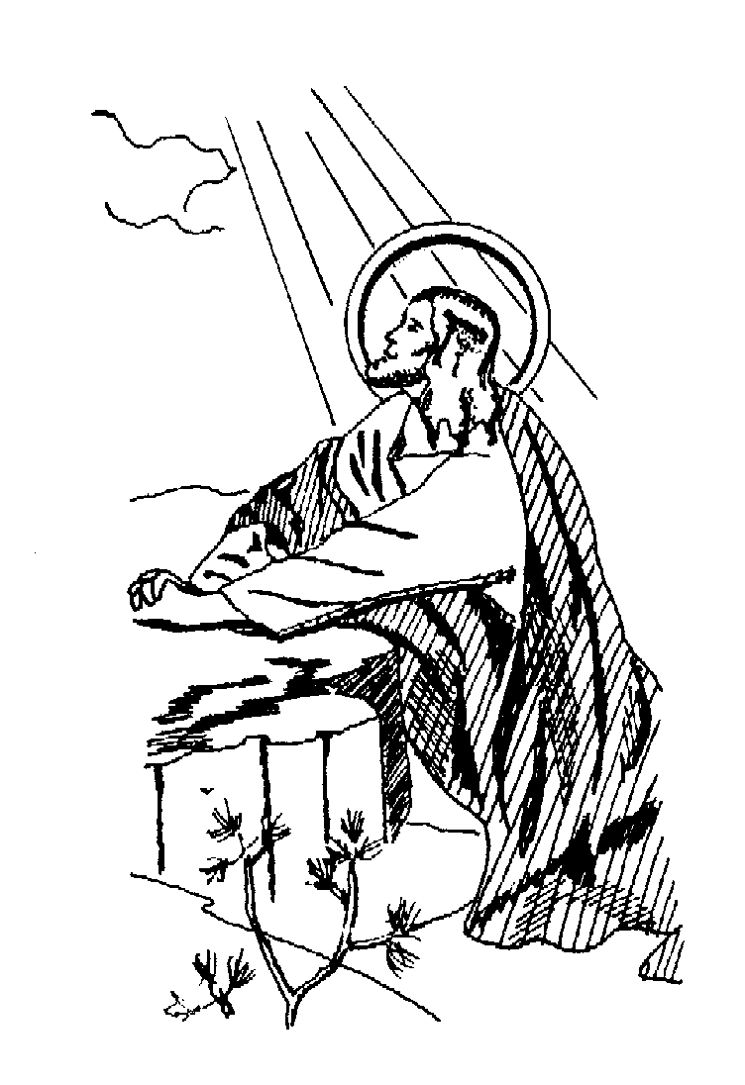
All because we do not carry,
Everything to God in prayer!

- Have we trials and temptations?
Is there trouble anywhere?
We should never be discouraged,
Take it to the Lord in prayer.
Can we find a friend so faithful,
Who will all our sorrows share?
Jesus knows our every weakness,
Take it to the Lord in prayer.

- Are we weak and heavy laden,
Cumbered with a load of care?
Precious Savior, still our refuge,
Take it to the Lord in prayer.
Do thy friends despise, forsake thee?
Take it to the Lord in prayer!
In His arms He’ll take and shield thee,
Thou wilt find a solace there.

WHAT A DAY THAT WILL BE


What a day that will be
When my Jesus I shall see
When I look upon His face
The one who saved me by His grace
When He takes me by the hand
And leads me through the Promised Land
What a day, glorious day that will be

(Repeat)

WHAT A MIGHTY GOD WE SERVE ????
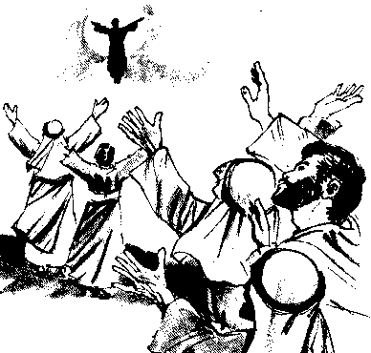
What a mighty God we serve,
What a mighty God we serve,
Angels bow before Him,
Heaven and earth adore Him,
What a mighty God we serve.

WIND, WIND

REFRAIN:

Wind, wind, blow on me; wind, wind, set me free;
Wind, wind, my Father sent the blessed Holy Spirit.

Jesus told us all about you,
How we could not live without you.
With His blood the power bought,
To help us live the life he taught. (REFRAIN)

When we’re weary you console us;
When we’re lonely you enfold us;
When in danger you uphold us,
Blessed Holy Spirit. (REFRAIN)

When unto the church you came,
It was not in your own but Jesus’ name,
Jesus Christ is still the same,
He sends the Holy Spirit. (REFRAIN)

Set us free to love our brothers;
Set us free to live for others,
That the world the Son might see,
And Jesus’ name exalted be. (REFRAIN)

VICTORY IN JESUS

- I heard an old, old story, how a savior came from glory,
How He gave His life on Calvary to save a wretch like me.
I heard about His groaning, of His precious blood’s atoning,
Then I repented of my sins and won the victory.

REFRAIN:

O victory in Jesus, my savior, forever,
He sought me and bought me with His redeeming blood,
He loved me ere I knew Him, and all my love is due Him,
He plunged me to victory, beneath the cleansing flood.

- I heard about His healing, of His cleansing Pow’r revealing,
How He made the lame to walk again and caused the blind to see,
And then I cried “Dear Jesus”, come and heal my broken spirit,
And somehow Jesus came and brought to me the victory. (REFRAIN)

- I heard about a mansion, He has built for me in glory,
And I heard about the streets of gold beyond the crystal sea,
About the angels singing, and the old redemption story,
And some sweet day I’ll sing up there the song of victory! (REFRAIN)



