Servant Heart Emmaus Walk # 34
March 3-6, 2016
Camp Whispering Pines

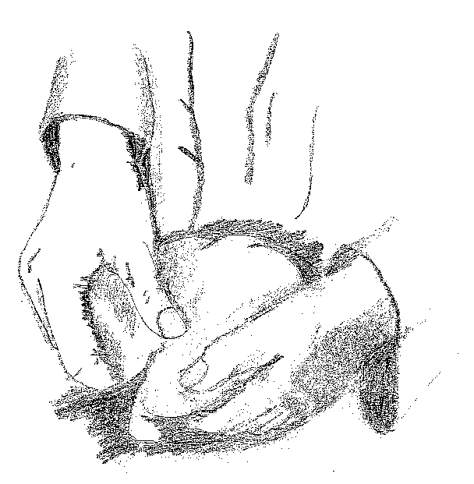

“. . .and their eyes were opened in the breaking of the bread.”
Luke 24:31



